The Ni-Wumpf
System 80
Replacement CPU
Manual

Copyright 2005 Ni-Wumpf Ltd.

Revision D

Overview 4
UBQ Project Goals 5
Implementation 6
Service 7
Design 7
Hardware 8
Software 8
BIT Test 9
Programming the CPU 9
Installation Caveats 9
Mounting... 10
Diagnostics and Bookkeeping 12
CPU Self Test 12
SETUP 12
DATA 13
HARDWR 13
OPTION 14
Command Console 15
Troubleshooting 20
Warranty 24
Appendix A - Emergency Programming Procedure 25
Appendix B – Sound Board Paddle 25

Overview
“Well, and here we go again” – It’s not clear where this quote comes from, only that it seems to fit perfectly right where it is. And, for as long as I have been putting off writing this manual, it has been only these six words that have consistently been select candidates to begin this manual with. Every once in a while though, it would be gratifying to know just why things are the way they are, and what particular synapse had collapsed in a mind-bogglingly fiery suicide in order to present you, the reader, with this stimulating, yet irrelevant thought. It is interesting to note that a ‘Google’ search for these same words aimed at some hint at what repressed memory coughed up this persistent idea reveals absolutely nothing helpful, apart from a completely different tangent somewhere along the lines of George Bush quotes that apparently have a lot to do with a thought that I did not have in mind when I was quoting it.
“Brought to you by the makers of other fine products, like the Gottlieb System 1 CPU”. Better. More marketable. And much closer to the mark of what you would expect a manual to begin with, but still only relevant in the fact that both products from Ni-Wumpf have the word “CPU” in them. Aside from this similarity however, the products are pretty much nothing alike, which is nice if you like to write manuals, but quite frustrating when you have just determined that much of the work done previously along these same lines will not actually be of much help at all now.
All right then, let’s take a stab at an overview of what we’re dealing with here in the vain belief that whatever the big picture is, it is not at this time, armed as well, and will not in fact, be stabbing back. There are a lot of Gottlieb System 80 games out there, and a lot of titles as well: fourteen System 80 games, twenty System 80A games, and twenty-two System 80B games – if the Internet Pinball database project is accurate. This is good, and bad. Good, in that, there is a market for a replacement CPU here. Bad, in that, there is a lot of work to be done if one CPU is going to handle 56 very different titles. Late in 1999, when the seeds of this project were first sown, these were the very thoughts drifting around my already badly twisted imagination. Now, if you have any experience at all with our first foray into replacement pinball components, (let’s be immodest here - the first replacement CPU ever to hit the market,) you may remember that Ni-Wumpf does things, well, differently. There are a lot of reasons for this – none of them spectacularly valid enough to convince anyone else but the principles of the company that, indeed this is the way to go about releasing a CPU to support pinball games whose original brains have melted. However, were you fore-armed with that experience, it should not then, surprise the reader, that this new CPU should be completely askew, and far beyond the imagination of what a normal approach would take to tackling the issue of; “how do we design a CPU that can be flexible enough to support three architectural implementations, and yet adaptable enough to handle 56 different code variants”.
Heh, heh, heh… truly, I wish I had majored in chemistry instead of computer science, because the imagery of bubbling beakers, and crackling flames would really be much more appropriate here than any mental picture I could conjure up to portray what goes on in creating these things. I mean, how entertaining can design workstations, scattered electronic components, and old moldy Dunkin’ Doughnuts coffee cups really be in preparing the reader for what actually went into the board currently in their possession? It’s no wonder then that there are no movies about computer scientists, because despite the word “scientist” in the title, the role is completely unappealing to the Hollywood screen guild. No amount of bizarre adjectives clustered around any marquee touting the phrase “computer scientist” is likely to interest the average 14 yr. old looking for stimulating adolescent entertainment. Just as well, in this case, because, it is largely not this audience for which this manual was written for and the feeling that once engendered this sudden train of thought regarding the media marketing appeal of computer professionals has now, thankfully, passed.

UBQ Project Goals
By early 2000, enough notes had been written, research performed, and mental commitment made to realize that, in fact, a solution to the problem of how to write fifty six different games for this new board design could be achieved. Moreover, if this solution could be applied to these three different Gottlieb platforms, it was not beyond reason to assume that the same approach could be taken for the early Bally, Game Plan, Allied Leisure, and Zaccharia games. The solution was simple – get someone else to do the work. …at least, the work of writing the game logic for these old games. Then Ni-Wumpf could focus on designing and building the hardware. It’s not so far-fetched – all that had to be done was to create an environment where the typical pinball enthusiast could take his creativity to bat on a piece of software that would easily enable him to write game code - and see the results of that effort. Now, skipping right over the complexities of just what that would take, and assuming blissfully, that such a software tool already existed, I jumped right into doing what I like doing best; making LED’s blink on new hardware prototypes. This is where consideration of all of the other gaming platforms played a much larger role. I.e., what core functionality did a pinball CPU need to possess in order to perform all of the I/O that each CPU could manage individually? The kind of questions that go into this recipe for hardware include; how many switches in total do we need to consider? How many are hardwired? How many are optos? What about lamps? Do we need to handle such intricacies as dimming these lamps? …number of solenoids? And what would it take to interface to a dot matrix display controller, or a multi-voiced sound board?
Without ever answering these questions, and quickly applying the same avoidance logic that went into the decision to ignore any important details in just how we would create a software environment to write code for this board, the next step to this design process was to assume that, if indeed, the software could be written easily for this hardware, that it too, could just as easily be implemented. So, given that the core set of hardware existed already, what would it take to adapt such hardware to the different platforms that we were targeting? Well, this too is just about as simple (if you’re getting the hang of this process); separate the hardware into two parts – the part that we already know can do everything that any pinball CPU should possibly require, and the part that actually has to interface with the other parts that we already have a pretty firm handle on. …because these parts have wires coming from them that expect to plug into the CPU that we have designed so convincingly.
Now, on the surface, this process may seem a little strange to the reader, but in fact there is a name for it, it’s called “virtual computing”. …and abstract interface layers …and quite a few other bits of nonsense that people who have a good firm grip on reality completely ignore whenever they encounter such mentally distracting terms. But rest assured, after hearing about this design concept from such prestigious obfusticators as IBM, on a particularly vicious design spec. I once put together for the new terminals to be used on the floor of the NY stock exchange, I can assure you that computer scientists do this sort of thing all of the time …to varying degrees of success.
In short then, the goals that we set out were pretty straight-forward, and can be easily tabulated as the following:
- Design a software coding environment that anyone could easily use to write game code for our new board.
- Design a board that is adaptable enough to be modified for use in every different gaming platform.
- Make a lot of money, and retire to Bora Bora, where apparently, there are a lot of scantily clad babes who are really into pinball.
“…so this is what they did.”

Implementation
The overall project of creating the System 80 CPU is broken down into several smaller modular projects, as hinted at above;
- The integrated game development environment (IDE), now completed as the first step toward the process and has been used to generate five of the System 80 games already. It is this tool, accessed via the web, and executed in the designer’s web browser, that gives the game coder the software tools necessary to write the logic for a game – the syntax of lighting lamps, firing solenoids, and working with variables and routines available on each of the different hardware platforms (in this case the System 80 design).
- The online compilation system, which is also complete, couples with the IDE to produce executable code for the board. This takes the game logic, translates it into compile-able code, links it with the hardware libraries and produces the online output that is then available to the developer for download and subsequent ‘burning’ to the board.
- The core hardware design is the next step that, coupled with a base-level hardware library to communicate with, provides the I/O necessary to provide such capabilities as lighting a lamp, firing a solenoid, outputting a value to a display, and scheduling events for real-time maintenance of what the game should be aware of doing. It is this hardware definition that defines, for example, that the maximum switch matrix size is 14 by 16, that there are up to 256 addressable solenoids, and that there are three other possible peripherals not yet defined that could be fed off an 8-bit bus with read, write, IRQ, INT and select logic signals.
- The platform application programming interface (API) that constrains the core hardware API to just what is used by the System 80 platform (for example); an 8 x 8 switch matrix; a 3 x 16 eight-segment display matrix; a 4 x 12 lamp matrix; 16 different sounds, and 10 different solenoids.
- The platform IDE routines that give the programmer all of the default programming functionality needed to offload coding of such generic tasks as what happens when the ball hits the outhole, and a new ball should be popped into the shooter lane; what a game in idle shows on the displays; tilt penalties; handling extra balls; scoring points that show up on the displays; and most other default functionality that nearly all System 80 games will possess, and for which a coder of one particular game should not have to address.
- The System 80 game board design itself – which went through seven different prototype/revisions before arriving at the product this manual was eventually written for. It is this hardware that integrates the core hardware with the platform hardware to provide the specific I/O functionality for the system 80 games.
- The VHDL code – virtual hardware coding to interpret the core hardware command functionality into output logic specific to the platform it will run on. This code is imprinted on any CPLD/ASIC components on the board.
- And to aid in getting the right sounds for the occasion, the System 80 sound tracker – a simple design to monitor and display each of the sounds generated when a specific switch is activated. It is this PCB that allows the game coder to match up the sounds generated by the original game PCB with their sound ID for use in the routines being coded.
And with the completion of these projects comes the first product release for the ubiquitous pinball CPU; the System 80 CPU.

Service
The board is designed with as many surface mount components as possible to take advantage of the cost and availability of complex high-pin count components. These components form the core hardware functionality of the board – physically and electrically. However, at the edge of the logical output from the board, where the CPU interfaces directly with the hardware of the pinball circuitry, the position is reversed, all PTH components were used. In this way, the architecture is comprised of a crucial high-density set of core surface mount components inside surrounded on the outside by PTH interface components that protect this circuitry from damage. Any damage that can be directed to the board from faulty driver board components, mysterious cabinet re-wiring, and plain operator error is going to wind up on these “buffer” components that can easily be serviced in the field with standard available parts. At no point should the surface-mount components need to be replaced. It is this design philosophy that should provide a blend of the best characteristics from each component to provide a high density circuit design that can easily be serviced by the end user.

Design
Those who are quick to recognize one of the system design terms from above are going to have a jump on the how we physically implemented the board. But for those who missed that hint, we have to back up to the decision that most board designers face when looking at putting together a PCB for a high-impact environment: surface-mount components or through-hole? For even small, modern designs the answer is simple – surface mount components. But for the pinball environment, where there are high surge currents, a lot of physical knocking-about, and frequent power cycling – the issue of component failure and subsequent service of these components becomes a big concern. Here are some of the features of each technology;
Feature | Surface Mount Component (SMT) | Through Hole Component (PTH)
Cost | For most parts offered in both form factors, the SMT components are generally 60 - 70% of the price of the equivalent PTH component.
PCB acreage | Similarly, the SMT equivalent to the PTH part will generally occupy only 20 – 40% of the space on the board (and consume a lot less power.)
Ease of Assembly | Great if you’re a SMT shop with IR ovens, hot-air rework tools, and computer-controlled placement systems. Very difficult otherwise. | A lot of work by hand. The higher the pin count, the longer it takes – tedious but do-able.
Serviceability | Very difficult no matter the tools used, replacing a 144 pin component almost guarantees missing connectivity on one leg or more in the process. | Very serviceable. Customer friendly in this respect.
Availability | All modern components are released as SMT form-factor. | Many components are no longer being offered in PTH versions.
Production Life Time | Good production run times, though many complex products end-of-life pretty quickly. | Longer but unpredictable end-of-life production runs. Some components have run 25 years already, others just 15.
Table 1 – Features and Benefits of PCB component design

Obviously, there are desirable features in each manufacturing form-factor, and what we tried to do in the design was to select each component for it’s best features to give the board high performance, yet serviceability in a pretty rugged environment.

Hardware
The hardware of the CPU is made up of several independent processors tied together via the main system data bus and handshake logic. The main processor is the Z80 CPU controlling operation of the other processors, and running the actual game code. Next in line is the PIC controller that handles user I/O to the RS232 interface, user and system timer functionality, and all game input from the switch matrix. Last is the high-density output controller - the FPGA, handling all game output lines, including displays, solenoids, lamps and sounds. Finally, there are several additional I/O control lines available to expand the core functionality of the system to include communication to external processors/components such as sound cards, and expansion I/O controllers.
RAM, Flash ROM, boot ROM, and interrupt/address decode logic is all performed in the PSD chip.
All output from the FPGA to the displays, lamps, and sound board is buffered through 74LS240 chips. Output to the solenoids is buffered via 7406 driver chips.
The CPU and FPGA are clocked at 4MHz, while the PIC is clocked at 20MHz.

Software
Each of the processors has independent code segments stored in various components on the board. The Z80 and FPGA code is normally loaded through the RS-232 port, and downloaded into the PSD Flash ROM. The bootloader code and CPLD logic is downloaded directly into Flash ROM via Header H3. The PIC code is downloaded directly onto the PIC via Header H5. Only the game code (and occasionally, the FPGA code) is user upgradeable via computer interface with the RS-232 port.
Because the board is designed to handle all of the System 80 games with only room enough on the system to download a single game, it should be normal to expect the system to be re-programmed several times for use in different games than the board was originally configured and shipped as. Please refer to the Command Console section below for further details.

BIT Test
On power-up, the system will reset and execute the first section of code in the bootloader, which is to blink the LED on the board once. The next self-test is a loopback test to check communication with the PIC controller, and lastly, the CPU will download the FPGA with its code segment. Be aware that the full download procedure lasts around six seconds after the first blink before the system fully initializes, therefore a power-up delay of this amount of time is to be expected (though, since this is not any different than the original CPU, the lag should not come as a surprise). Should any of these tests fail, the board will not go into full operation.
A failure of any of these major components is indicated by the number of blinks the LED will blink after the initial blink; Should the CPU blink once again (OK – let’s make this clear here – once more, for a grand total of two blinks) it indicates a failure to program the FPGA. A third blink will indicate a failure of the NVRAM memory. Having the CPU blink a total of four times indicates a PIC chip controller failure. Please refer to the Diagnostic section for more details on troubleshooting the hardware.

Programming the CPU
The CPU is designed to support all of the System 80 games, it is also intended to support updates to the game code once available online. This is done by hooking a computer up to the CPU board, and downloading (“burning”) the new image into flash memory on the board. No other equipment is required to re-target the CPU board for a new game other than a PC, and a serial cable. Code updates, and new game images can be obtained from the Ni-Wumpf website: www.ni-wumpf.com.
Bear in mind that the code supplied with the Ni-Wumpf CPU is not always compatible with the operation of the original CPU. In some cases, the changes were intentional, others are a result of modern circuitry, and still others are the result of too many Margaritas, low blood sugar, and a callous disregard for proper coding technique when operating a pinball machine. However, if you uncover a flaw in the operation of the game that does not fall under any of these categories and which you suspect a coding error has occurred – notify Ni-Wumpf with a description of the “bug” and a method by which to reproduce it. We will look into, validate it, and fix it (if necessary) - and because this new CPU is flash reprogrammable, you, the lucky user, could actually have a new pinball image ready for installation by the end of the day!

Installation Caveats
The System 80 replacement CPU was designed to be a plug-in replacement for the original System 80 CPU, but one will quickly notice, the size of the board is about one-half that of the original. This brings up issues in several areas; mounting, cabling, and position. The installer will immediately notice that the connectors to the CPU (figure 1) are located in the same basic position as the original CPU, except for J2, which is located on the top of the CPU rotated 90º counterclockwise. This connector is installed by bending the J2 connector over the top of the CPU from it’s original position – there should be no cable strain in this new position. Because each connector is slotted exclusively for the cable going onto it, it is impossible to install the wrong cable on the wrong connector. The CPU is oriented so that the component side faces out. The long side of the board with three connectors faces down. On the left side of the board goes the power cable from the power supply (J1); bottom left is the connector for the playfield switch matrix (J6). On the bottom middle of the board, is the connector to the front door switches (J5) next to the connector for the driver board (J4), on the bottom right. On the right side of the board is half of the two connectors going to the displays. To install the display cables, connect the lower of the two cables (J3), to the connector on the left, fold the cable over the top of the board, and connect the upper cable (J2), onto the top-most connection.
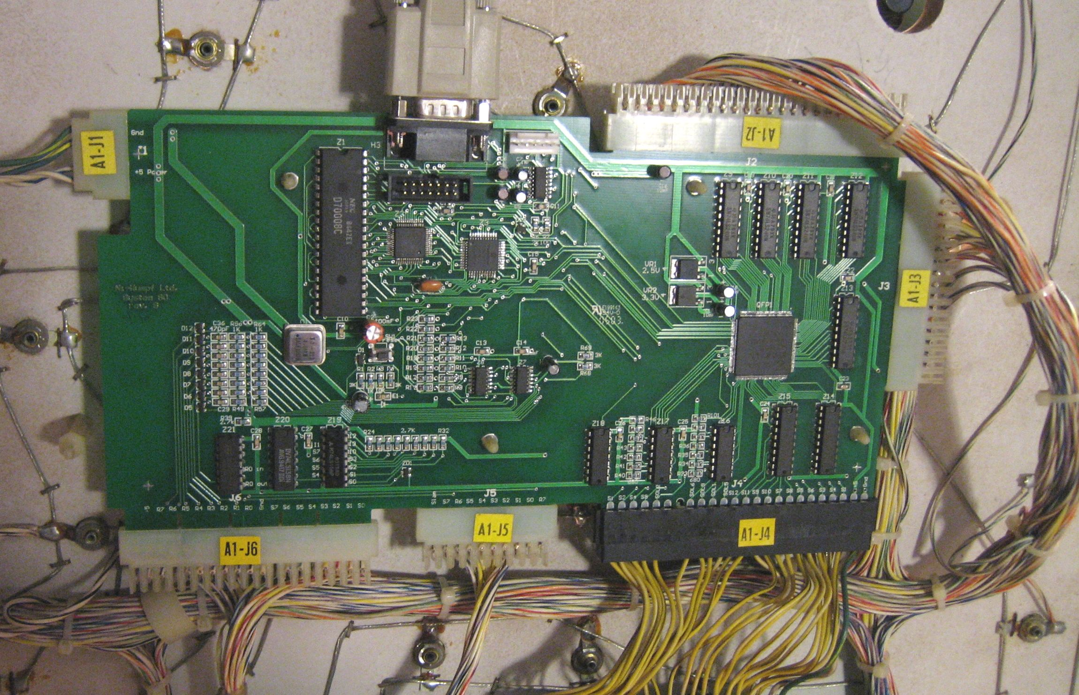
Figure 1 - Ni-Wumpf replacement CPU showing connector designation.

Mounting...
Mounting the new board in place where the original Gottlieb CPU was, is a simple process made only somewhat more complex by the size of the board. Because the new board is so much smaller than the original (about ½ the size), it only mounts on half of the posts available. Using the lower right-most posts, the board presses neatly into place without modification to the existing system. There will be three nylon posts unused above the CPU, and one additional post unused to the left.
It has been noted by early adopters at the “Gameroom Warehouse”, that the board mounts ½” too low on these nylon mounting posts (the board is now ½” lower than the original board), and that this position interferes with the spinner motor in the backglass for the Black Hole game, other beta testers did not experience this. However, if this is the case on your machine, the workaround for this situation is to unbolt the spinner motor, which is mounted asymmetrically on the internal backglass door, rotate the unit 180⁰, and re-mount it in the door. The asymmetric mounting will then lower the motor below the board.

-WARNING-
-WARNING-
-WARNING-

BEFORE the game is powered up with the new CPU there are several guidelines that must be followed to prevent the board from suffering damage.
First, and foremost; if the interboard connector between the CPU and the driver board (J4) has suffered corrosion damage, the pins on this cable should be replaced. Corroded pins will be brittle, and prone to imminent failure, while the lack of spring tension on a corroded pin will also make for poor contact. Granted, the CPU has circuitry that is a bit more immune to the type of failure that bad pin connectors can cause, it is still very possible to short out this board with a bad driver board, or a bad cable.
Second; a bad display will destroy the new CPU just as readily as it did the old CPU. Please be sure that all of the displays to be used are checked out before you power up the board. This can be a difficult procedure, especially when checking out an unknown display means possibly frying the test CPU if it is bad. Fortunately, there are not that many bad displays that fall into this category. To err on the side of safety is the best approach, and this means not to use a display whose functionality is questionable
Third, the connectors; J5 and J6 are just as likely to be corroded as J4, and the pins, just as brittle. While these connectors cannot seriously damage the CPU because of their condition, it is imperative that they be checked and repaired to attain proper game operation.
Fourth, no connector should be removed from the CPU while it is powered up! This can damage the CPU, especially the display cables. Always power-down the CPU before removing any connectors.

Diagnostics and Bookkeeping
There are two ways to use the CPU to help diagnose the operation of a game; the first is to use the diagnostic self-test button inside the front door of the game. Pressing this puts the game in CPU self test. The second is to use a computer linked up to the CPU to communicate directly with the system to test it’s functionality.

CPU Self Test
Statistical analysis, option settings, and diagnostics for the CPU board is organized under four separate sub-menus from the main entry into the self test routine. When you first press the test switch inside the game's front door, you should see the displays blank, and the player 1 display show the word SETUP in rough alphanumerics. (I don't want to hear any hassles about how "well" the 8-segment displays in the game display letters, so just keep that off the service call comments!) The SETUP menu is used to set and adjust game specific features. Pressing the test switch again will offer the operator the chance to enter the DATA menu, used for displaying and resetting bookkeeping statistics for the game. The next main menu is for HARDWR, used for testing the operational condition of the various components of the game. The last menu available is the OPTION menu, and like the original CPU, this gives you the chance to set and modify different playing/bookkeeping options common to all the System 80 games. When the test switch is pressed yet again, the game will give the operator the chance to exit the test mode; (“DONE”) and resume game play. To enter into any of the menus currently displayed in the player 1 display, press the replay button on the front door. This will select the option shown, whether it is a menu, or the DONE command.

When a sub-menu has been selected, the player 1 and player 2 displays will begin to show the fields available for that sub-menu, while the player 3 display will show the value of that field. To advance the field displayed, depress the test button. To increment/cycle the value displayed in the third display, repeatedly press the replay button. To zero this value press the test button and the replay button simultaneously. (In this case "simultaneously" means to be pressed together as closely spaced in time as can be expected. The easiest method to accomplish this is to press and hold the replay button, then depress the test button, and then quickly release both.) Selecting the DONE field in a sub-menu, will return the user to the parent menu, clearing the player 2 and 3 displays. To advance onto the next field, after modification, of the value, depress the test button once again.

SETUP
Fields in the SETUP menu will contain customizable settings for the specific game used. In general the fields will at least contain the following variables.

Field Description
DIP SWITCH Emulate the setting of the option dipswitches on the original CPU board; a ‘1’ would “set” the DIP switch for location 31; a ‘2’ would “set” DIP switch 32, and a ‘3’ would set both. Game specific code would then query this setting for how to operate. Note: this setting is generic, and will be overridden if more game specific variables are programmed into the end of this test menu by the game programmer.
BALL SAVE Number of seconds from ball launch to allow the player a second chance if the ball drains too quickly – a value of ‘0’ disables ball save.
FIRST THRESH First replay threshold value
SECOND THRESH Second replay threshold value
THIRD THRESH Third replay threshold value
HIGH SCORE High score to date
ENABLE 4HSTD Provides memory of the last four high scores, and (if enabled) scores 3 credits for beating the HSTD, 2 credits for beating the second highest score, and 1 credit for beating the third or fourth highest score.
ENABLE MILION Enables game memory of high scores above 999,999 and allows display of more than six digit scoring via scrolling the display from right to left.
GSOUND ENABLE If the game is equipped with the “Pinball Pal” GSound board, this setting will enable extended functionality on that board (when available).
<GAME SPECIFIC> The game programmer may add game specific variables to this menu, such as “Row EB Reset” on Counterforce to reset the Extra Ball available lamp at the end of the flashing advance – refer to the manual for more info. on these variables, or the game programmer.

Table 2 - Game SETUP fields and their meaning

This is the only sub-menu where depressing the replay button, and holding it closed will be detected by the CPU and will auto-increment the following fields; FIRST THRESH, SECOND THRESH, THIRD THRESH and HIGH SCORE.

DATA
In the bookkeeping sub-menu, the following fields are available for interrogation:

Field Description
TOTAL CREDS total number of credits paid for via coin entry
GAME STARTS total number of games started
COINS LEFT number of coins registered through the left coin chute
COINS RIGHT number of coins registered through the right coin chute
TOTAL REPLAS total number of replays awarded
NUMBER SLAMS number of slam tilts detected
NUMBER EBALLS total number of extra balls awarded
NUMBER TILTS number of normal tilts detected

Table 3 - Bookkeeping fields and their meaning

Bookkeeping information is completely reset when the selection is made to restore factory settings (see below).

HARDWR
In the hardware testing sub-menu, the CPU can test the operation of the displays, the lamps, the coils, and the switches. While exercising any of the tests below (except for the switch test), any switch closure on the playfield will interrupt the running test, and terminate it.

DISPS - Selecting the display test will begin the first half of the display test, which is to count from ‘0’ to ‘Y’ repetitively in every display digit for all of the displays. If you depress the replay switch again during this test you will toggle the test from this half of the test, to the second half, which is to show a marching digit across each of the display digits counting from ‘0’ to ‘Y’ repetitively.

LITES - Selecting the lamp test will continuously pulse the lamps on and off for around three minutes before timing out.

COILS - Selecting the coil test will cycle through all of the system coils available, including the special coil assignments used via lamp circuits connected to transistor drivers. While the coils are pulsing, the corresponding coil number will be displayed in the status display. Consult your game specific manual for the game being tested to determine the coil assignment number to the playfield solenoid. This exercise will repeat also for about three minutes before timing out.

SWITCH - In this test, the CPU scans the playfield for any newly detected switch closures and reports the switch assignment in the player 3 display. One second after the last switch is detected, the display will return to show a "0" in the display, indicating that the CPU is scanning for newly detected closures. If two or more switches are depressed at once, the CPU will display them, but you will only be able to see the last switch indication in the display. Be aware that this test cannot determine if any switches have been stuck closed since before the test began, as it can only detect newly activated switches.

SOUNDS – Initiating the sound test will output each sound incrementally, from 1 to 15, each time the game start button is depressed. The sound number will be shown in the status display as it is being played. Please note that some sounds will not be interrupted from playing by pressing the start button.

INIT E – Selecting this function restores factory defaults to the NVRAM. The CPU will flash the displays when it is done resetting the audits, high-scores, and features. It was determined that the entire diagnostic set-up to the games had gotten just complex enough to justify an option to reset all of the NVRAM settings to the factory default.

OPTION
If you consult the original game manual for the System 80 games, you will find that all of the parameters that were selectable via the DIP switches on that board are also selectable via this menu, with a few added fields at the end.

Field Description
LEFT COINS left coin counter setting (see table 5 for matrix) .
RIGHT COINS right coin counter setting (see table 5 for matrix).
CENTER COINS center coin counter setting (if equipped. See table 5 for matrix).
CREDIT LIMIT Maximum credits allowed (from 0 – 15). A value of “0” enables free play
ENABLE MATCH Match feature: 0 - disabled; 1 - enabled
NUMBER BALLS Number of balls/game (from 3 to 7)
SPECIA CREDIT Special award: 0 - extra ball; 1 - replay
TOTAL TILTS Penalty for tilting: 0 - game over; ‘x’ > 0 - loose ball in play after tilt mechanism detects ‘x’ tilts within 30 seconds.
SHOW CREDS Show credits: 0 - disabled; 1 - enabled
COIN SOUNDS Play credit tune on coin entry: 0 - disabled; 1 - enabled
SCORE SOUNDS Play game sounds: 0 - disabled; 1 - enabled
CHUTE MATCH Chute control: 0 - allow separate coin chute control
1 - set coin chute 2 the same as chute 1
SHOW HSTD Display high game to date during game idle time: 0 – disabled;1 – enabled
IDLE ANIMAT Enable playfield animation during idle mode of the game; 0 – disabled;1 – enabled
SPECIL OVERRD Operator override, when enabled, it prevents more than one special being awarded during a single ball’s play; 0 – disabled;1 – enabled
SPECIL AWARD Award three replays for beating the high score to date, and, if enabled, 2 replays for beating the second highest score, and 1 replay for beating the third of fourth highest score: 0 - no award; 1 – enabled
EXBALL LIMIT Maximum number of extra balls allowed at any one time
Table 4 - Options settings and their descriptions

Setting Description
0 one coin/credit
1 one coin / 2 credits
2 one coin / 3 credits
3 one coin / 4 credits
4 one coin / 5 credits
5 one coin / 6 credits
6 one coin / 7 credits
7 one coin / 8 credits
8 one coin / 9 credits
9 two coins/credit
10 two coins / 2 credits²
11 two coins / 3 credits²
12 two coins / 4 credits²
13 two coins / 5 credits²
14 two coins / 3 credits
15 three coins/credit
Table 5 - Coin counter multiplier table

Command Console
The CPU is equipped with an RS-232 port to allow direct operator access to specific CPU functionality and parameters. It also provides the developer a method to download new code to the board for test and operation.
In order to access the CPU via command console it must be directly connected to a computer via an RS-232 cable. Please note: the CPU is not designed to operate normally as a pinball controller while simultaneously responding to command console input. The conflicting I/O may cause it to crash.
The cable used is a straight-through connection with the male connector attached to the CPU and the female connector to the PC. Any serial communications program capable of file transfer will perform the task required on the PC. References in this manual assume that the user will be using the default Microsoft Windows terminal program; “Hyperterminal”. The communications configuration is set to; 8 bit serial communication, no parity, and 1 stop bit (8-N-1). The data rate is 19200 baud (see below). When performing file transfers, the CPU expects 1KByte Xmodem communications transfer protocol and the terminal emulator program must be capable of “send”ing a file with that protocol. Be aware that “Hyperterminal” is a buggy program prone to crashing in its’ own right, and it may well crash during file transfer, but normally its’ capable of doing the job.
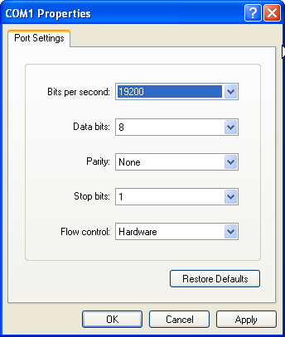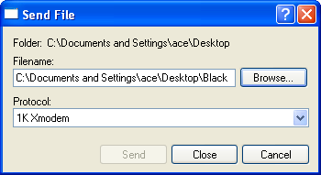
Figure 2 – Hyperterminal Connection Settings
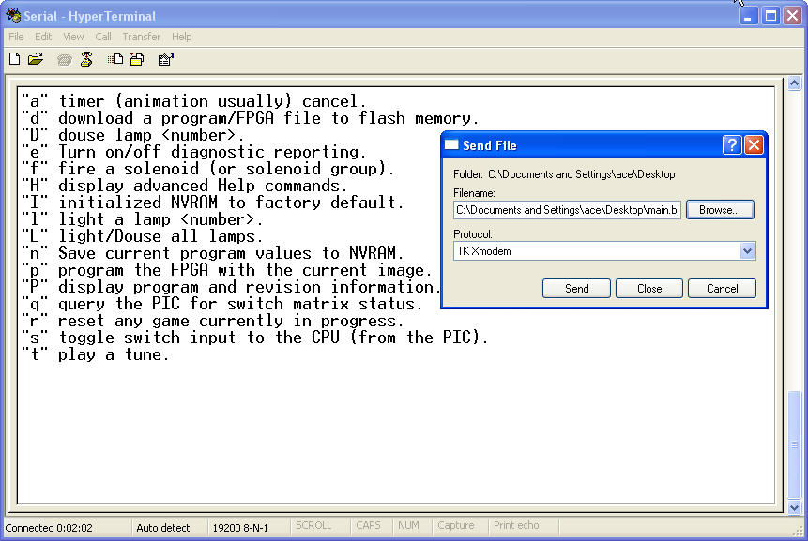
Figure 3 – Hyperterminal – Help menu
All of the commands to debug game code, test game operation, and update the CPU are accessible from the same command level. Entering the first letter of a command will execute that particular command. For commands that require one or more parameters, the CPU will prompt the use for further input.
Commands to test each individual lamp, solenoid, display digit, and sound output are all available through the command interface with the CPU. Additionally, the status of each switch in the matrix can be read, and switch monitoring of status can be enables/disabled. The table below lists the basic console commands available to the user, and is displayed by typing ‘h’ for “help”.
Command Description
‘a’ Disable system timer from interrupting the CPU.
‘d’ Download a binary image to the system. On entry to this command, the CPU will enable update to one of two areas in memory. The CPU will prompt for update to the ‘f’ – flash area, or ‘p’ – program area of memory. Entering “dp” will prepare the system for program update.
‘D’ Douse lamp. The CPU will prompt for the lamp number to turn off (0 – 48).
‘e’ Turn on diagnostic mode. Repeated entry of this command will toggle diagnostic reporting to the console.
‘f’ Fire a solenoid. The CPU will prompt for the solenoid to energize (numbered 1 thru 9).
‘h’ Displays the help command set, (as shown in figure 3 above).
‘H’ Displays the advanced help command set.
‘I’ Initialize NVRAM to factory default values, and clear all bookkeeping data.
‘l’ Light lamp. The CPU will prompt for the lamp number to turn on. Valid values are 0 – 48. Repeated entry of this command will toggle the lamp on / off.
‘L’ Light all lamps, this is a toggle command that will also douse all of the lamps lit once the command is re-entered.
‘n’ Save all console modified settings to NVRAM .
‘P’ Program the FPGA with the current code.
‘p’ Display game name, and revision levels of the current program image.
‘q’ Query the static switch matrix status. This displays a hexadecimal matrix of what switches are closed / open. (closed = ‘0’, so a line that reads “5 - 3FF7” means that switch number 53 is closed, on the System 80 games the “3F” can always be ignored, and the “F7” indicates a closure on the fourth return line counting from 0 on the right most bit)
‘r’ Reset the CPU. Re-enables timers, and re-loads NVRAM
‘s’ Enables diagnostic reporting of switches as they are activated. Repeated entry of the command toggles reporting.
‘t’ Output sound. The CPU will query for which sound to play (numbered between 1 and 15).

Table 6 – Basic CPU commands

There are also extended functionality commands to reset the CPU, and modify it’s core operation, such as scanning rates, and energization timing. These are displayed via the extended “Help” command menu as shown below.

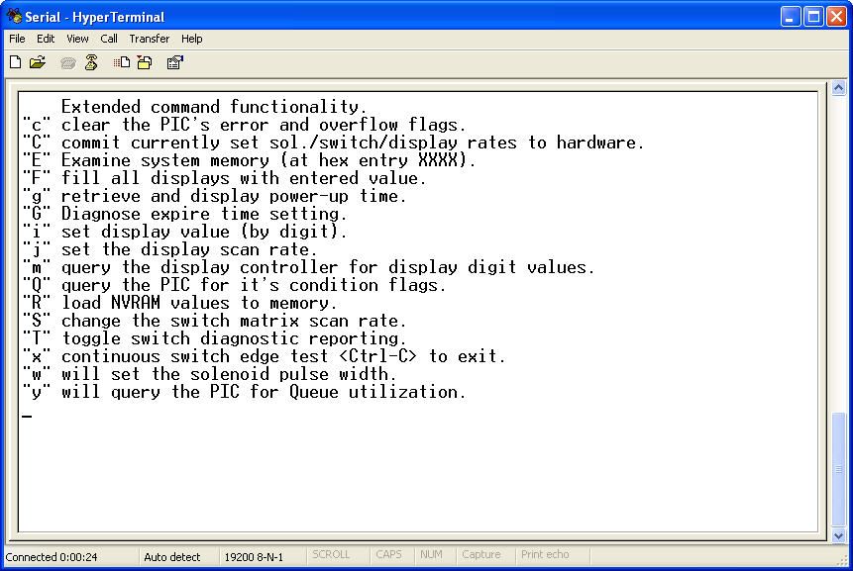
Figure 4 – Extended command menu.

Command Description
‘c’ Clear any error conditions in the interrupt controller.
‘C’ Commit hardware settings to NVRAM (such as strobe rate, solenoid pulse width, etc.) These settings are only modified temporarily via the ‘J’, ‘S’, and ‘w’ commands, and are lost after power cycling the CPU.
‘E’ Examine system RAM memory. Used with a memory map of the game code when it was compiled, this command will display variable values during runtime in hex. So when examining a character byte variable, a returned value of “41” is an ‘A’. An integer value would take two bytes, starting, for example at E480 with a value of “00”, and at E481 with a value of “0A”, you would find the integer value of 10, etc..
‘F’ Fill all display segments with the value entered into the command line. Valid entries are ‘0’ – ‘30’. The corresponding character representation is then shown in every segment of the displays. For example entering in the value 11 will show a ‘B’ in all of the displays.
‘g’ Display the CPU time (hours / minutes / seconds / milliseconds since power-up) – accurate enough to keep track of time since the board has been powered-up, but not much good as a clock without continual power.
‘G’ Display the time for the next scheduled event timer to elapse.
‘i’ Enter a value to be displayed in a particular digit of the displays. Valid values are ‘0’ – ‘30’, and valid display digits are ‘0’ – ‘47’.
‘J’ Adjust the scan rate of the displays. By setting the scan rate to a lower value, the clock time between scans is decreased, in this way the displays can become brighter, although possibly blurred. Valid values range between 16 and 5000. Nominally, the rate is 3400.
‘m’ Retrieve the value of the digit from display memory. Valid memory locations are between ‘0’ and “47”. A value of “31” in display memory is a blank.
‘Q’ Retrieve the status flags from the PIC. If bit 1 is set in the returned byte, this indicates an RS-232 framing error (in communication with the PC). Bit 2 set indicates a transmit overflow error (from the PIC to the Z80 CPU). Bit 3 set indicates an overflow in the communications buffer (from the PC to the PIC). Bit 4 set indicates an overflow in the communications buffer from the Z80 CPU to the PIC. Bit 5 indicates that there is a pending timer loaded in the PIC.
‘R’ Used to reset the operating parameters of the CPU from NVRAM (from last power-up or when last saved to NVRAM). Helpful to reset any changed frequency/timing.
‘S’ Adjust the switch matrix scanning frequency. The switch matrix can be scanned at a rate between 250 to 8000. Each platform system has different electrical reactance characteristics that work best at different scanning rates. The System 80 rate is nominally 1480.
‘T’ Toggle the switch diagnostic reporting. Whenever a switch is activated, the corresponding switch number is reported to the PC console.
‘x’ Switch edge test. The CPU will continually query the PIC for switch matrix closures, on each cycle, it will upload all detected switch closures. Each cycle is approx. 1 second. Enter in ‘Ctrl-C’ to exit the test.
‘w’ Adjust the pulse width of the solenoid activation signal. The amount of time that the solenoid is activated will change the amount of power that it delivers. Each game platform may be different. The System 80 solenoids nominally are energized for 190 mSec.s, valid values are in the range of 1 to 250.
‘y’ Query the PIC for utilization of the input / output / RS-232 queues.

Table 7 – Advanced CPU commands

Troubleshooting
- Fault Isolation
Isolating what section of the CPU may be damaged in the case of operational failure will be necessary before any corrective action can be taken. The table below is far from complete, but is intended to help the operator isolate the faulty component / describe the correct procedure to help diagnose the board performance. Should some symptom exist that does not fall into any of these categories, you should reference the website (www.ni-wumpf.com) for further assistance and contact information.
The CPU should normally blink once during power-up to indicate that it is operational. Following this single flash, the game should enter idle mode after about 7 seconds, alternating displaying the high score to date, and the last game score. The CPU performs a number of start-up tests during this time to determine the operation of the peripheral controllers (PIC, and FPGA), and flash integrity. If any of these components, or their supportive circuitry, do not respond as expected, the CPU flashes the LED an additional number of diagnostic blinks to attempt to isolate the problem.
Symptom Possible Cause
No LED activity or LED lit continuously on power-up. | Verify that the following default signals can be seen at the points indicated; a clock signal at pin 6 of U1, a reset signal at pin 26 of U1 (when the reset switch is depressed), and of course, power is up to a good +5 volt level. Should any of these prerequisites be lacking, you will have to track back this problem prior to any further board troubleshooting. (Refer to schematics).  Boot up errors due to corrupt program memory, or incorrect program update can lead to this symptom as well, refer to Appendix A to attempt program recovery from boot PROM.  Probe the DATA and address lines for shorts or grounds. Normally, all address and data lines show logical activity. A stuck address/DATA line may be an indication that the Z80 (U1) is faulty and should be replaced. If all signals look good and the programming is valid, this is a return to factory problem.
LED blinks once at power-up. | FPGA program failure. This can be caused by a failure of the FPGA (U3) itself, or corrupt firmware for the chip. The first troubleshooting step to take is to download new FPGA code from the Ni-Wumpf site and program it to flash (refer to the Command Console section), and retest the board. If this does not solve the problem, the board should be examined for trace cuts or discontinuity of signals between the CPU and the FPGA. FPGA problems will be a factory repair issue.

LED blinks twice at power-up | This indicates a Flash memory problem. While not a fatal operation error, it will prevent the game from using NVRAM parameters such as thresholds, number of balls, etc.. Using either the game self-test button, or CPU console control, reset NVRAM to factory settings. If this does not resolve the problem the CPU should be returned for factory repair.
LED blinks three times at power-up | This indicates a PIC communications error. This is a fatal error, and indicates that the CPU should be returned for factory repair.
Lamps do not operate that correspond to one or more strobe columns (1 to 4) | Z14 may need to be replaced – this 74LS240 buffers outputs S0 through S3 (and LD0 to LD3)
Lamps do not operate that correspond to one or more strobe columns (5 to 12) | Z15 may need to be replaced – this 74LS240 buffers outputs to S4 through S11
Lamps do not operate that correspond to one or more lamp data lines | Z14 may need to be replaced – this 74LS240 buffers outputs S0 through S3 (and LD0 to LD3)
Solenoid 1, 2, 5, 6, 8, or 9 continually energized or will not energize. | Z16 may need to be replaced – this 7406 buffers solenoid outputs to solenoids 1, 2, 4, 5, 6, and 9
Solenoid 4, or 7 continually energized or will not energize. | Z17 may need to be replaced – this 7406 buffers solenoid outputs to 3, and 7, as well as outputs to all of the sounds
Solenoid 3 continually energized or will not energize. | Z18 may need to be replaced – this 7406 buffers solenoid outputs to solenoid 8
The same segment(s) on all digits in Display Bank A (player 1 and player 2) are stuck on or off. | Z9 may need to be replaced – this 74LS240 buffers segment outputs to display bank A
The same segment(s) on all digits in Display Bank B (player 3 and player 4) are stuck on or off. | Z10 may need to be replaced – this 74LS240 buffers segment outputs to display bank B
The same segment(s) on all digits in Display Bank C (timer/bonus and credit displays) are stuck on or off. | Z11 may need to be replaced – this 74LS240 buffers segment outputs to display bank C
A digit in the same position on all display banks (for player 1, player 3, and the bonus/timing display if present) shows brightly or does not light at all. | Z12 may need to be replaced – this 74LS240 buffers outputs for digits 1 through 8
A digit in the same position on all display banks (for player 2, player 4, and the bonus/timing display if present) is showing brightly or not lit at all. | Z13 may need to be replaced – this 74LS240 buffers outputs for digits 9 through 16
One or more sounds do not work | Check for output on pins 2, 4, 6, and 8 of Z17, if these show now activity try replacing Z17 (7416).
One or more switches are not recognized – corresponding to switches on one or more strobe signals | Check for the corresponding output strobe from Z19, (see schematic), if no output disconnect J5 and J6, and re-check. If still no output replace Z19 (74156).
Switches are not recognized from slam switch and those on return line 0. | Refer to schematic – check operation of Z20, and Z21 for correct operation replace as needed (74138 and 7408 respectively)
One or more switches are not recognized – corresponding to switches on a specific return line. | The return buffers are SMT components, and this may indicate a factory repair
CPU crashes/sporadically resets during game play | Generally, this is not a CPU problem, but rather an associated problem with the +5 voltage level. The problem can normally be reproduced by causing the CPU to energize a solenoid, while simultaneously energizing a non-CPU controlled solenoid (such as a bumper). This will stress the power supply enough to drop-out the voltage regulator or surge the ground. Check that all solenoids are the correct part number and that the snubbing diodes across them are working. Check for good ground connections at the power supply header pins. Check that the solenoid drive transistors are not “leaking”. Check the connector between the CPU and driver board for good connection. Check the power supply voltage regulator for a solid +5 volts.
CPU consistently fails to power-up; pressing the reset button corrects the problem | Check C1 for 47 micro-Farad capacitance, replace C1
Table 8 – Troubleshooting Chart

Warranty

The Ni-Wumpf replacement System 80 CPU is warranted against manufacturing defects and premature component failure, known as infant mortality, for up to 90 days after the date of it’s purchase. For this reason, it may be prudent to keep a copy of the receipt for the board handy, in case the need should arrive to lend some credibility to your claims as to when it was actually purchased. In the unlikely event that a part should fail on the board within this time frame, simply package up the board, with a copy of your receipt, and return it to the factory address mentioned on our website, with some note of explanation as to why we are receiving this unexpected gift. Your CPU will be repaired or replaced and returned to you as quickly as possible.
Failure of the system within the warranty period due to abuse, incorrect installation, or faulty game components, is not covered by this warranty. The purpose of this warranty should be quite clear: We are willing to accept responsibility for manufacturing defects of the boards we are building, and feel that 90 days is a sufficient period to determine if such a defect may exist. We are not willing to accept the responsibility of others who may install this board into a game that may be broken enough to cause the CPU to fail.

Returning Your Board for Repair
To determine the steps required to repair your CPU, it is best to gather the information necessary to get the board serviced, whether by yourself or the factory. First of all, be certain that the CPU is actually broken before calling it in for service, and the best way to ascertain this is to consult this manual in detail under the configuration and troubleshooting sections. Next, armed with the confidence that a smoking chip is indeed reason for repair, contact your distributor or refer to the website below to determine what steps to take next. If you intend to do the repair yourself, he will be the person with the parts necessary to replace the chips you deem necessary. He will also be the person with the knowledge of what repair costs the factory will be charging if you wind up sending it in for repair (and in the case that the company address should change, he will know what the current address for Ni-Wumpf will be).
Repair of the Ni-Wumpf CPU is performed at the factory for all SMT failures. However, because the board design is targeted toward isolation of SMT component by “edge” buffer components, it should also be reasonable to undertake repair of the these components yourself should you feel capable of doing so. Most of these edge buffers are freely available at electronics supply stores, also these parts may be purchased directly from the factory or your distributor if they are determined to be at fault. In the case of board repair being sent to the factory, return the board to our address mentioned on our website with a note describing the problem. Repair costs may be required in advance and may be determined by contacting the factory beforehand.

Ni-Wumpf LTD.
www.ni-wumpf.com

Appendix A - Emergency Programming Procedure
Any failure in the procedure to update the main Flash program will leave the CPU in an unusable condition. However, the boot ROM contains a recovery procedure capable of emergency update to the main system Flash. To enter recovery mode, strike any key on the PC within one second of reset/power-up of the CPU. The user should be prompted to enter a ‘b’ to begin the download procedure from boot ROM. Any other key press will abort the process and resume normal boot behavior. Review the description in the command console section, and be prepared with a new code image to download to the board. Enter a carriage return to prepare the CPU for the download, and then begin the transfer in Hyperterminal. Once completed, the CPU will reset itself.

Appendix B – Sound Board Paddle
There is a tool to aid in sound output diagnostics used for both programming new games, and to determine if your game is outputting the expected sounds from the driver board. It plugs onto the existing connector for the sound board. Please note! You must power down the game when putting this connector on or pulling it off from either PCB, failure to do so may damage the driver board. This little card will continuously cycle a digit value for each of the sounds it has last seen (up to 12 sounds buffered). To clear the card of the last sounds monitored, press the reset button.
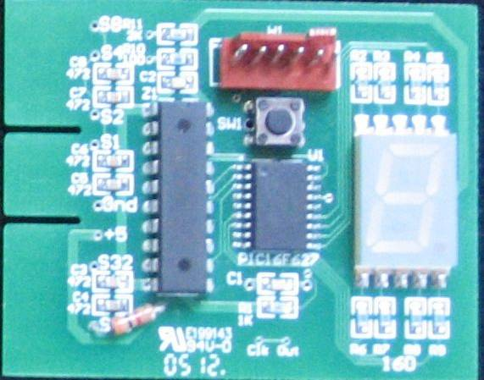
Figure 5 – System 80 sound board paddle

Contact Ni-Wumpf to find out how to obtain one of these tools.

Schematic supplement for the
Ni-Wumpf System 80
replacement CPU

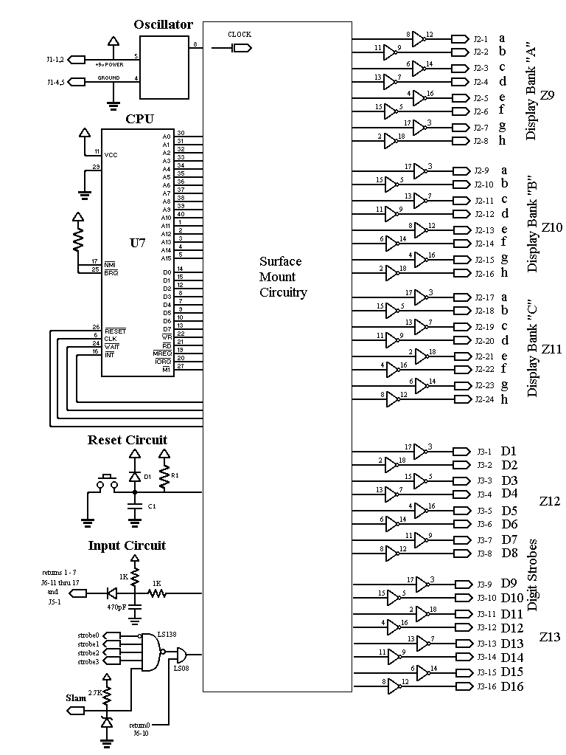
Figure 6 – System 80 Schematic – page 1
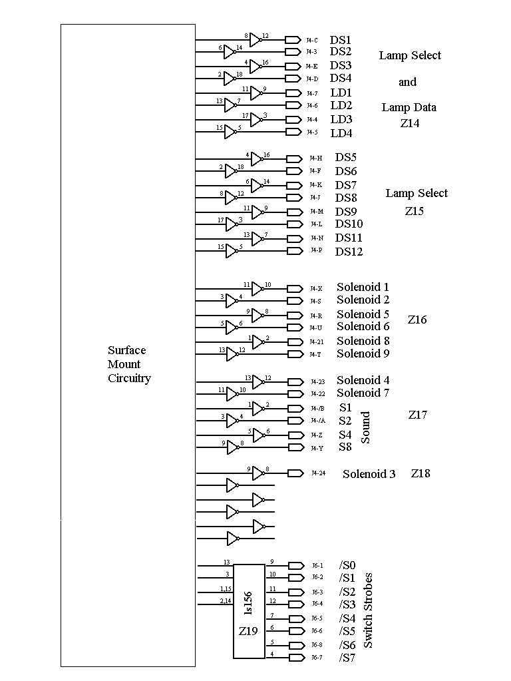
Figure 7 – System 80 Schematic – page 2
Designation | Quantity | Description
Z1 | 1 | Z80A CPU 4MHz
Z2 | 1 | STM PSD833F2-90M
Z2.1 | 1 | STM PSD833F2-90M
Z3 | 1 | Microchip PIC16F877-20
Z4 | 1 | RS-232 DR/RCV
Z7 – Z8 | 2 | Lo-Pwr Quad Voltage Comparator
Z9 – Z15 | 7 | Octal Inverter/Buffer driver with tri-state outputs.
Z16 – Z18 | 3 | Open-collector hex Inverter / Buffer driver
Z19 | 1 | Open-collector Dual 1-of-4 Decoder / Demultiplexer
Z20 | 1 | 1-of-8 Decoder / Demultiplexer
Z21 | 1 | Quad 2-input AND gate
QFP1 | 1 | Xilinx Spartan 2 FPGA XC2S50-5TQ144C
X1 | 1 | 20.0 MHZ Ceramic Resonator
O1 | 1 | 5V 4.0 MHZ Half Size Clock Oscillator
C1 | 1 | 16V 47uF Radial Aluminum Electrolytic Capacitor
C2 | 1 | 16V 100uF Radial Aluminum Electrolytic Capacitor
C5, C16 – C18 | 4 | 16V 10uF Radial Aluminum Electrolytic Capacitor
C6 – C9 | 4 | 50V 1uF Radial Aluminum Electrolytic Capacitor
C10 - C15, C19-C28 | 16 | 0.01mF nominal bybass capacitor
C29 – C36 | 8 | 470pF capacitor
R1, R4, R6, R68, R69 | 5 | 3K 1/8W SMD resistor
R7 | 1 | 100 1/8W SMD resistor
R3, R8 – R13, R16 – R23 | 15 | 10.0K 1/8W resistor
R24 – R32, R47 | 10 | 2.7K resistor
R33 - R46 | 14 | 680K resistor
R2, R49 – R64 | 17 | 1.0K resistor
D1, D5 - D13 | 10 | small signal diode
ZD1 | 1 | 5.1V zener diode
E1 | 1 | Red LED
H3 | 1 | Female 9-pin RS-232 header
H4 | 1 | 14-position 0.100” male header
H5 | 1 | 6-position 0.100” male header
SW1 | 1 | SPST switch
VR1 | 1 | 1 amp 2.5Volt voltage regulator
VR2 | 1 | 1 amp 3.3Volt voltage regulator

Table 9 – Bill of Materials for the Ni-Wumpf CPU

Thanks Mick!
No credit(s) are given until the second coin is inserted.
First coin gives one credit. Second coin gives two credits, unless a game has been started, in which case it acts as if it were the first coin of two and only gives one credit.
No credit is given until the third coin is deposited.
When attempting to update the CPU, it is important to have the file transfer setup configured beforehand.. I.e. before actually entering in “dp” on the terminal, start a “send file” transfer in the program (by clicking on the flying page icon), to get the file directory “browsed” to and selected, as well as the transfer protocol setup – finally cancel this fake send. It is best to place the code image in a directory that can be quickly navigated to from the serial communications program. Upon entering “p”, the CPU will erase the existing program memory, and enter into 1K XModem file transfer mode. The user should then initiate file transfer from within the terminal emulator program. Immediately after initiating Flash update of the CPU, the original on-board program is first erased, and then the download is begun. However, the CPU only allows 10 seconds for the file transfer to negotiate. After this time, the transfer times-out, and the CPU is left without any main program data. Therefore, a mistake in downloading to the CPU will disable the main programming interface. There is a recovery procedure to update the main flash program from the boot ROM described in Appendix A below.
On many System 80 games, the designers used external transistor driver circuitry to add solenoid functionality chained to a lamp output. While the game will automatically (through programming) account for this in self-test routines, the “light lamp” command allows the operator to bypass this restriction in order to directly energize those solenoids via the lamp output. Extreme care should be taken to “douse” any lamp that is attached to external drive circuitry in this way immediately after energizing it through this command (simply re-enter the command to toggle the lamp output). Ni-Wumpf will assume no liability for damage to the CPU, game, house or immediate neighborhood vicinity due to operator misuse of this command.

